A0 - eFolio – Week 3 & 4
  - Completed:
- EFOLIO TASK 3.1 (PASS AND CREDIT LEVEL)
- EFOLIO TASK 3.2 (DISTINCTION AND HIGH DISTINCTION LEVEL)
- EFOLIO TASK 4.1 (PASS AND CREDIT LEVEL)
- EFOLIO TASK 4.2 (DISTINCTION AND HIGH DISTINCTION LEVEL)

FIT5032 - LAB 3
CYR0006-Code/FIT5032-eFolio: FIT5032 eFolio repo

Summary – Completed in lab 3:
- EFOLIO TASK 3.1 (PASS AND CREDIT LEVEL)
- EFOLIO TASK 3.2 (DISTINCTION AND HIGH DISTINCTION LEVEL)

3.1 Bootstrap-powered VueJS app running with Activities 1-6 completed
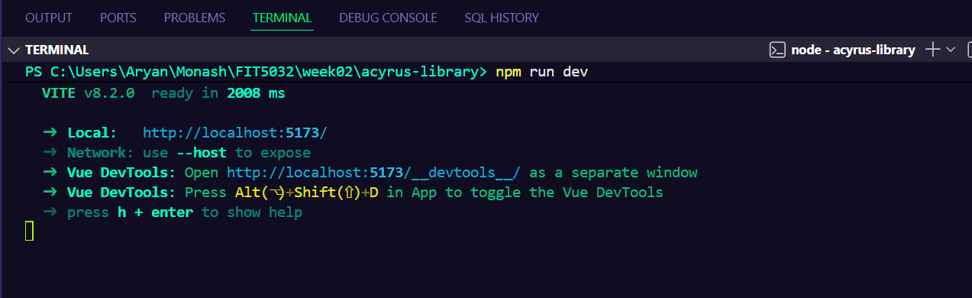
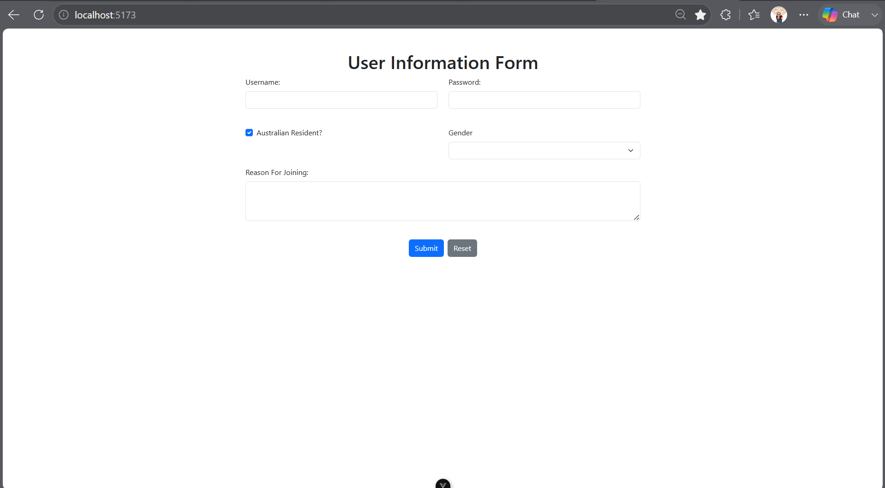
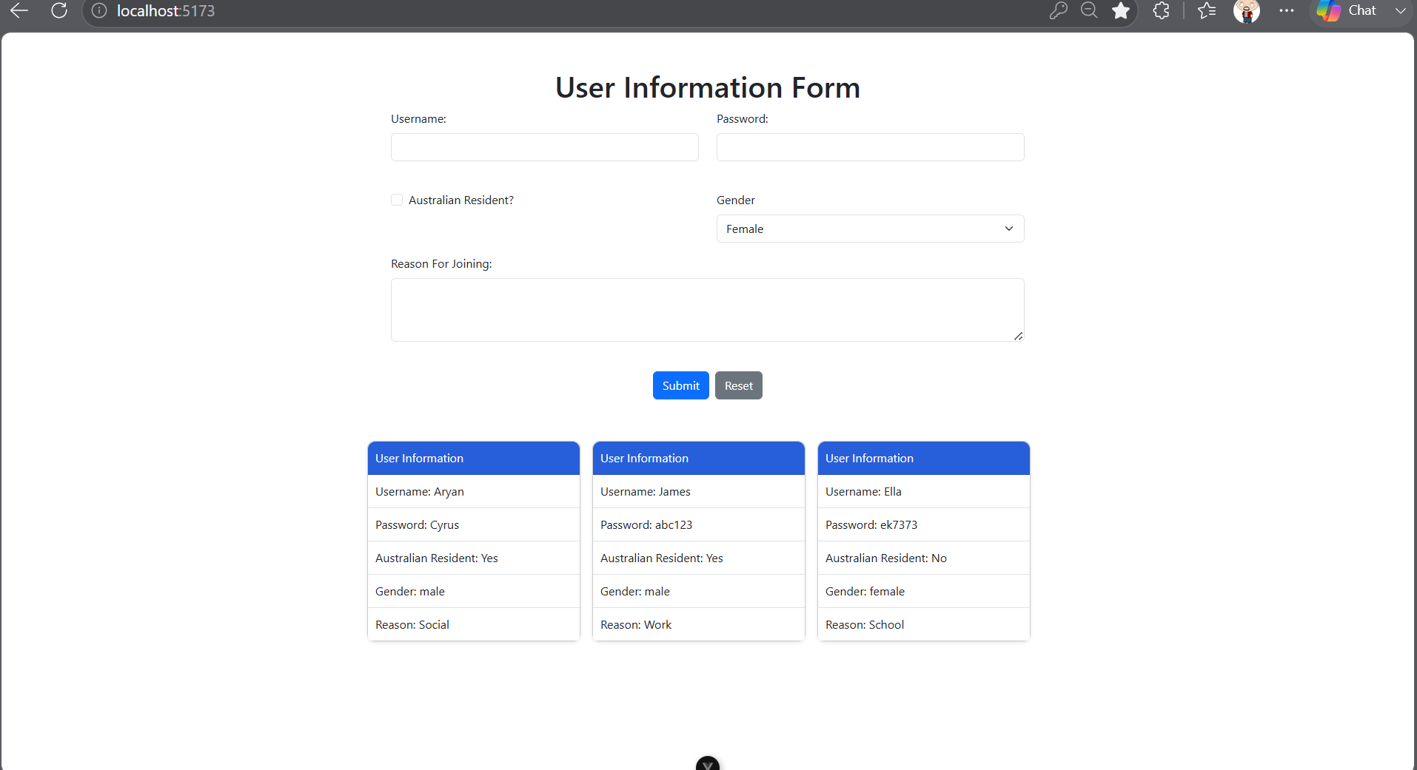
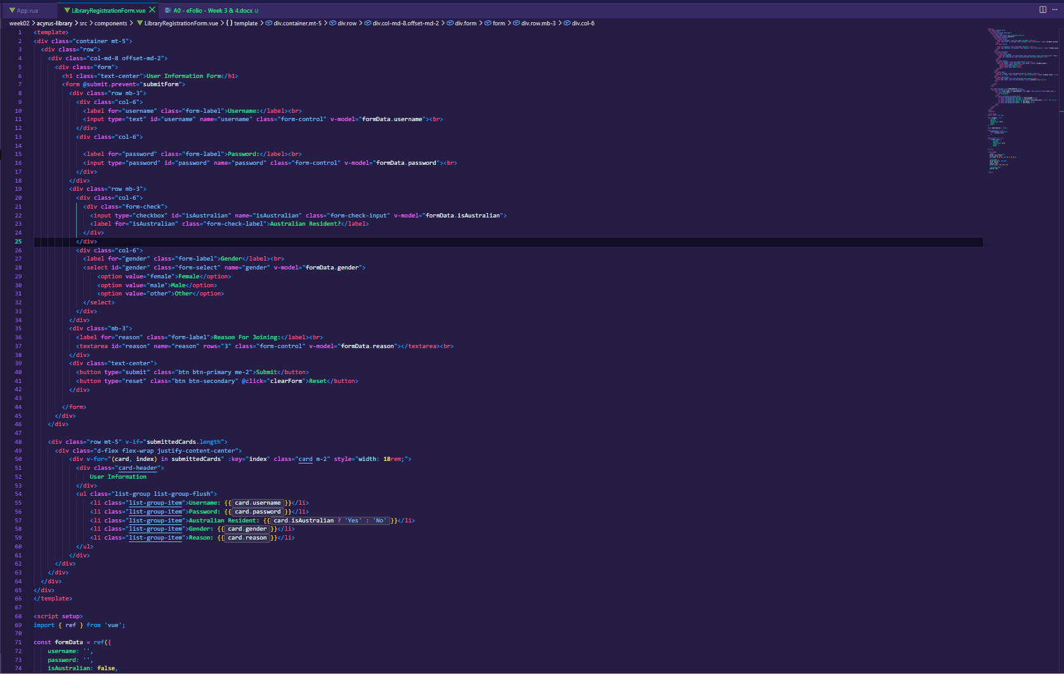

3.2 Use of breakpoints
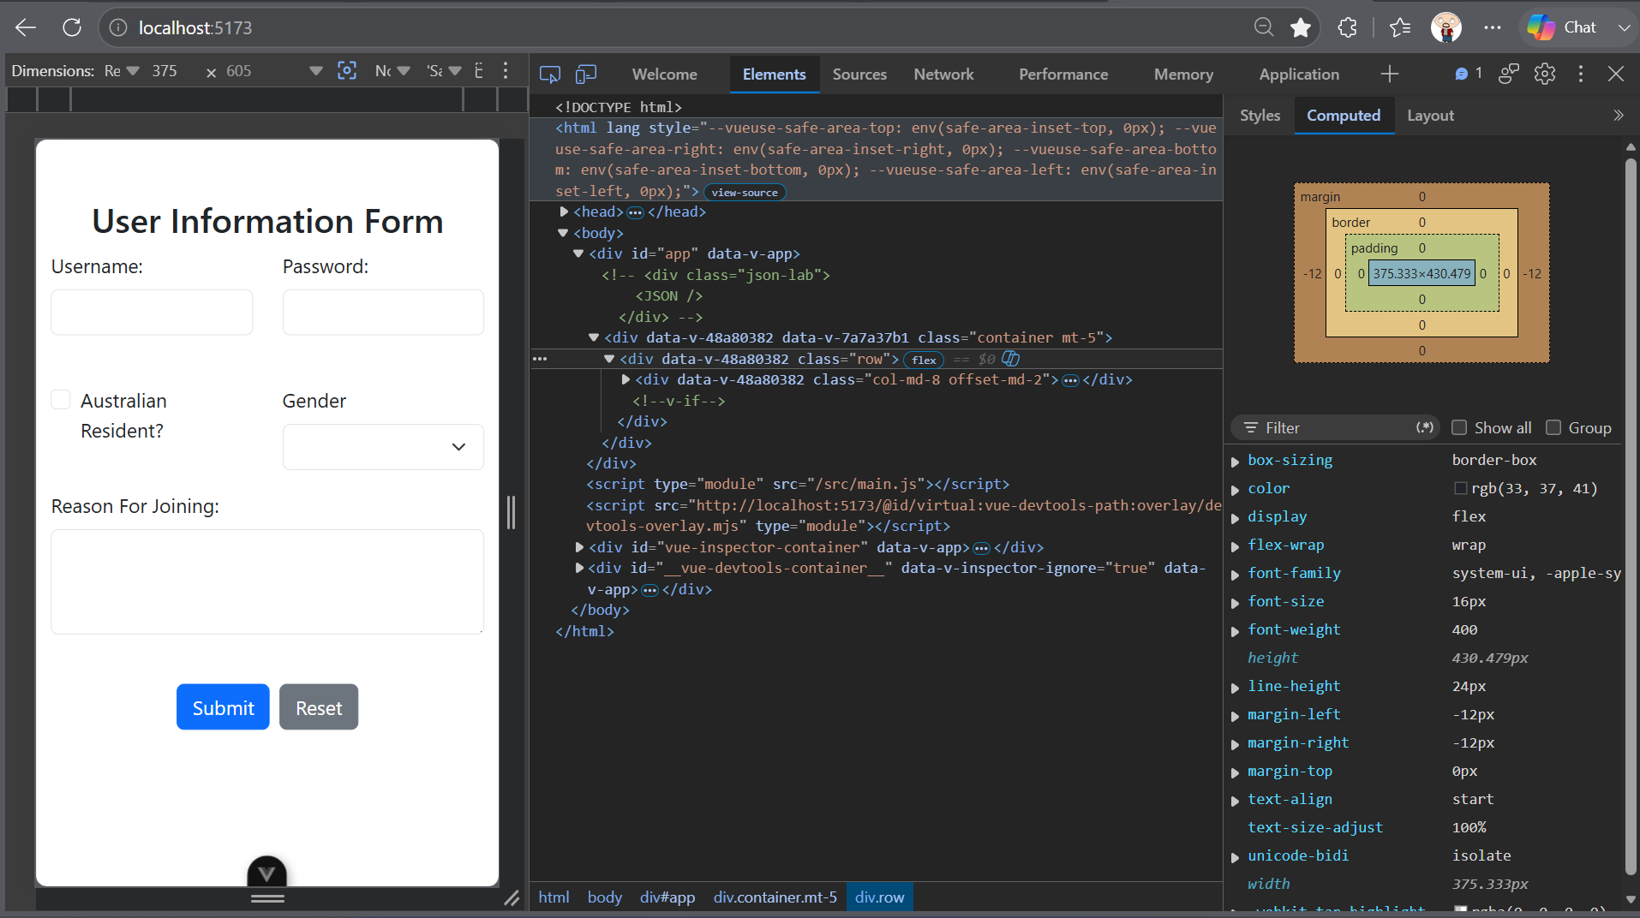
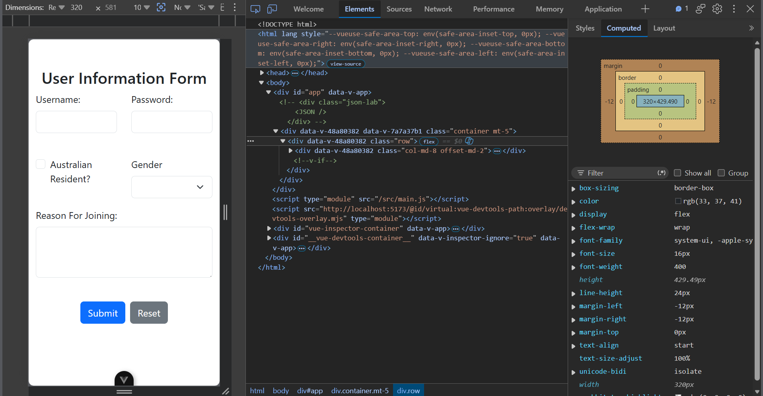
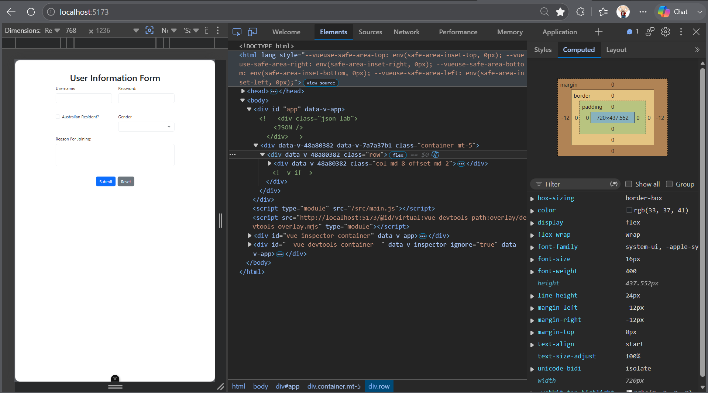
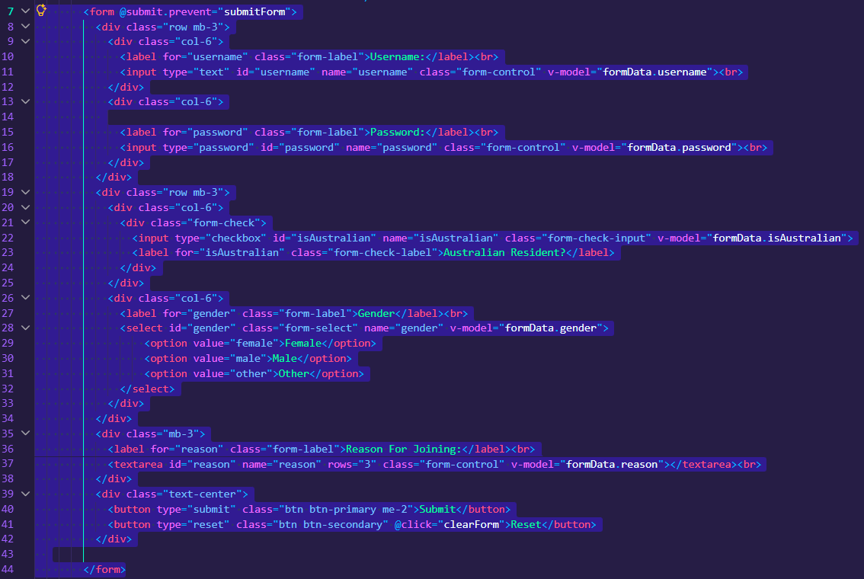
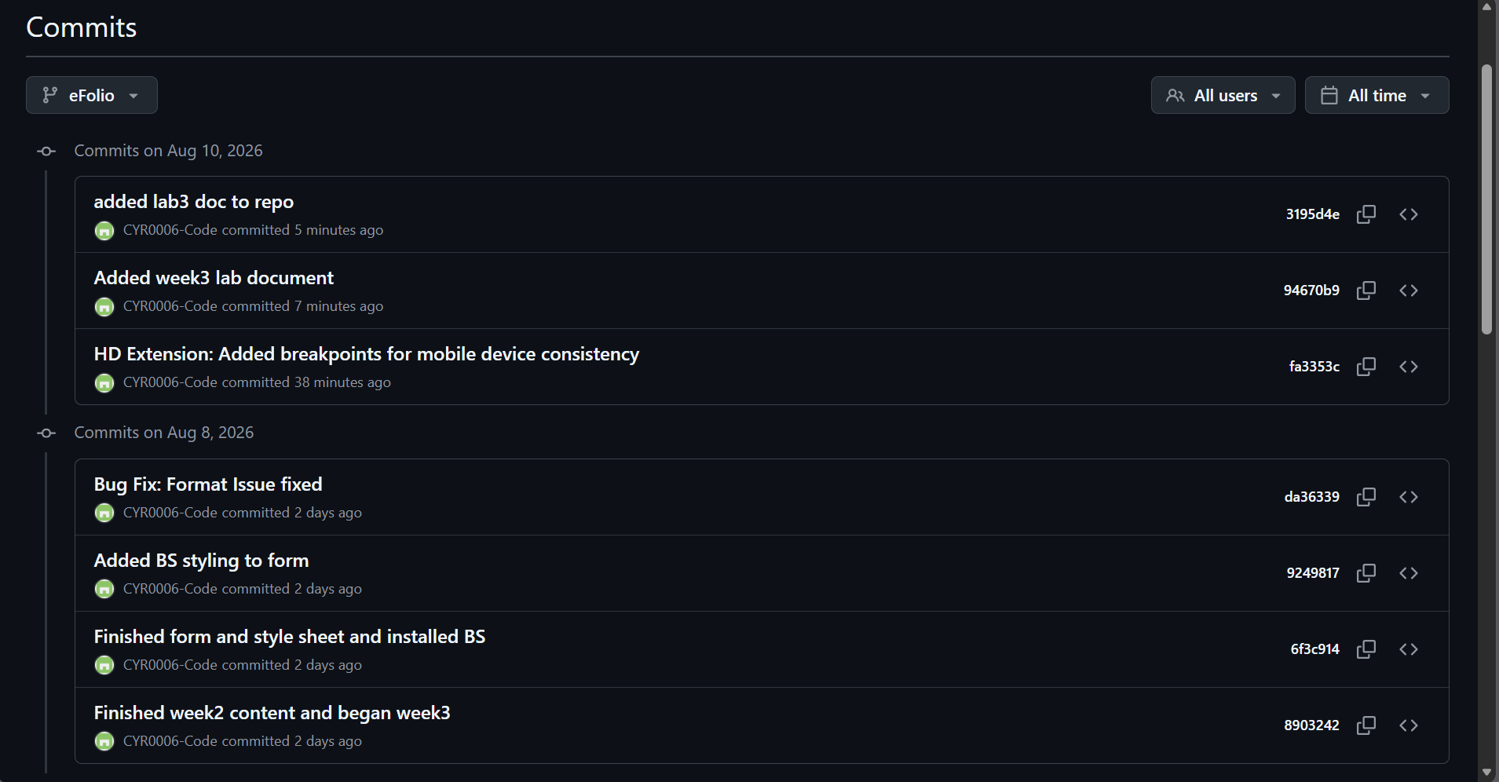

FIT5032 - LAB 4
CYR0006-Code/FIT5032-eFolio: FIT5032 eFolio repo

Summary – Completed in lab 2:
- EFOLIO TASK 2.1 (PASS AND CREDIT LEVEL)
- EFOLIO TASK 2.2 (DISTINCTION AND HIGH DISTINCTION LEVEL)

Task 1
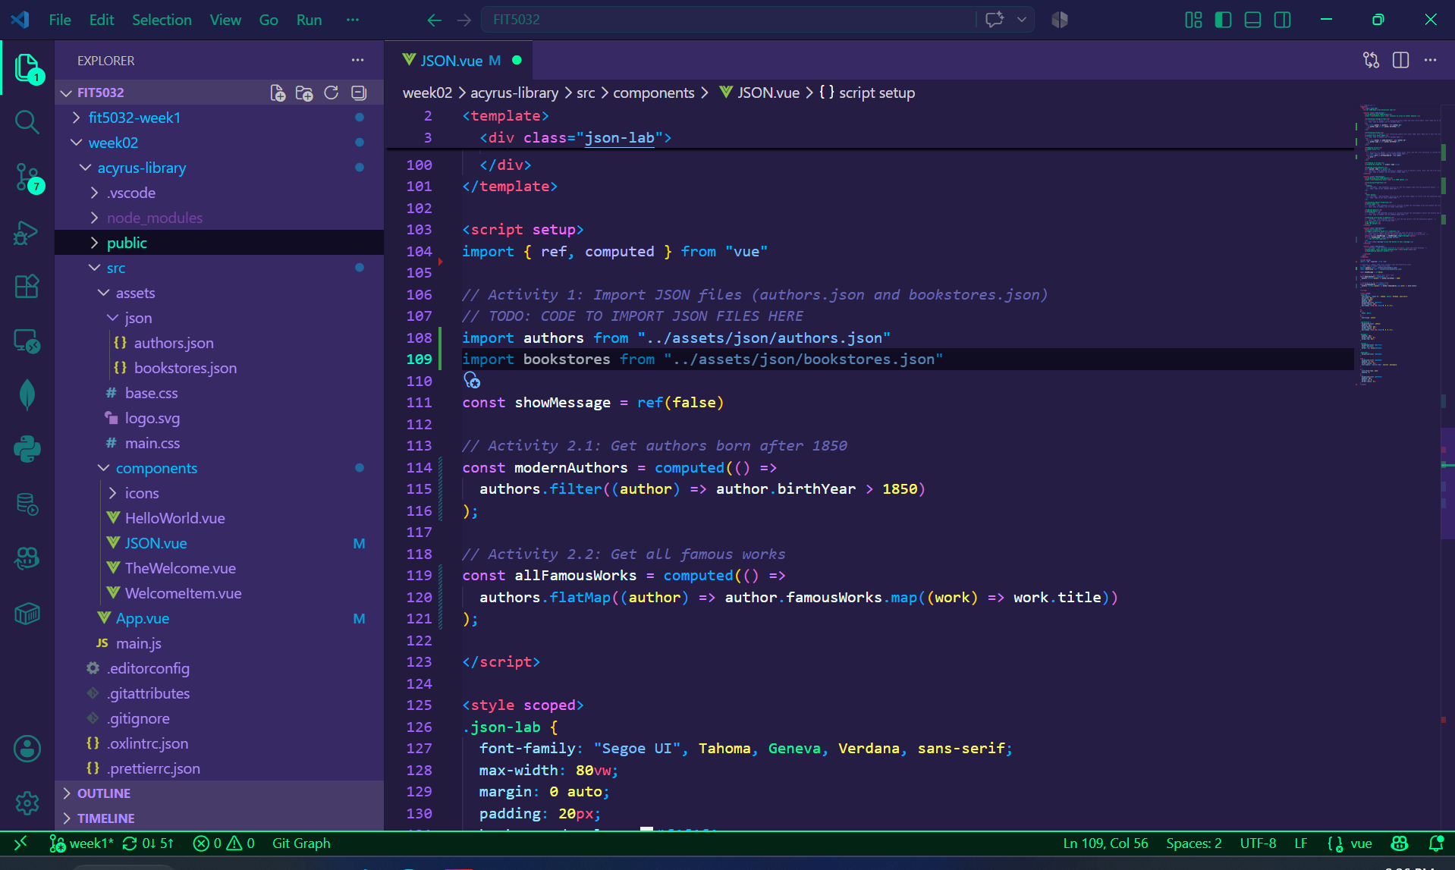

Task 2

Task 2.1
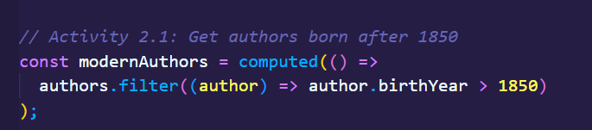
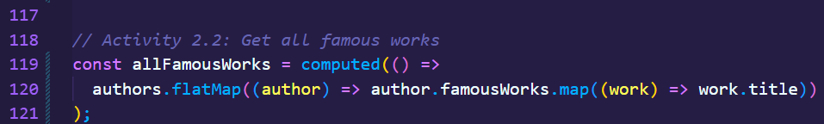
Task 2.

Task 3

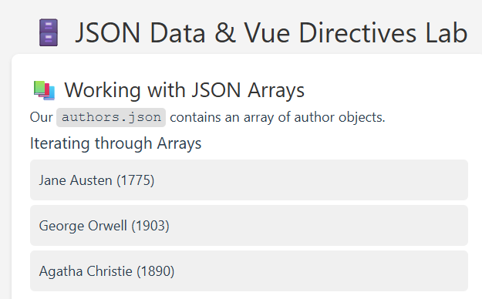
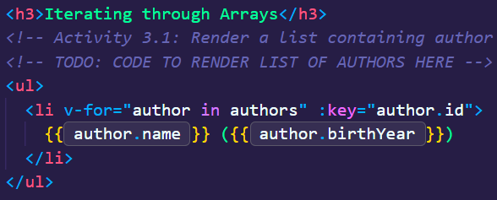
Task 3.1

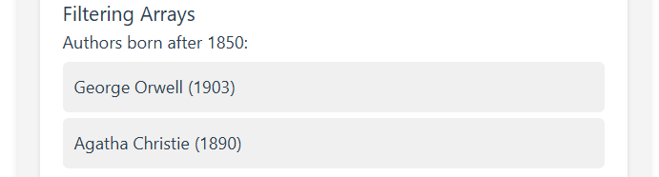
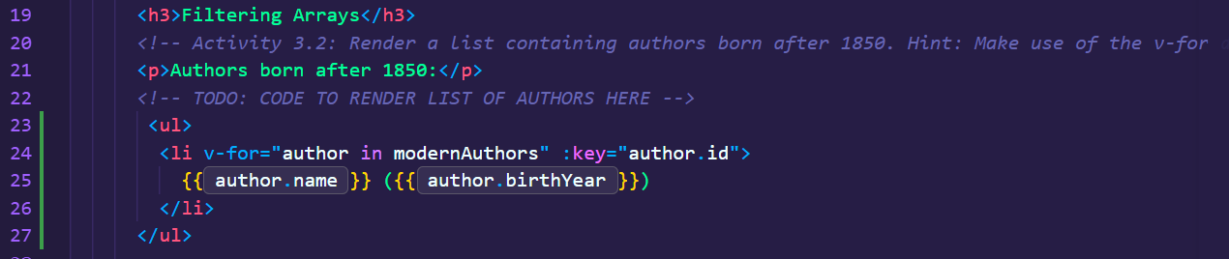
Task 3.2

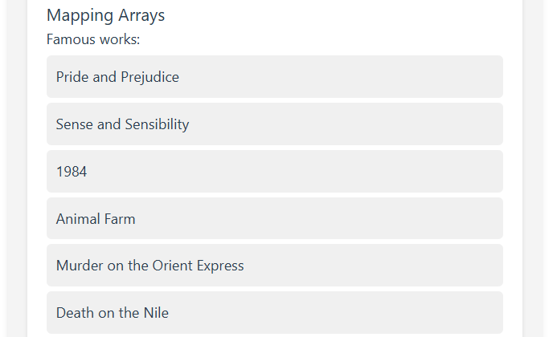
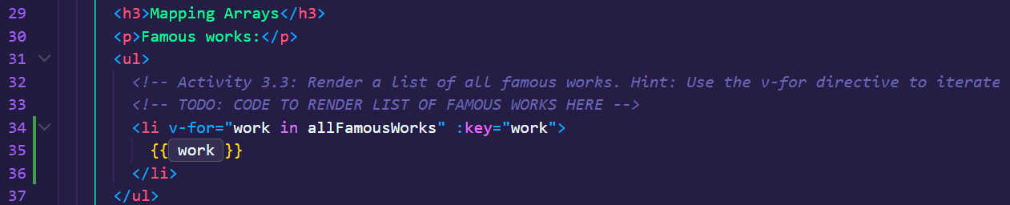
Task 3.3

Task 4

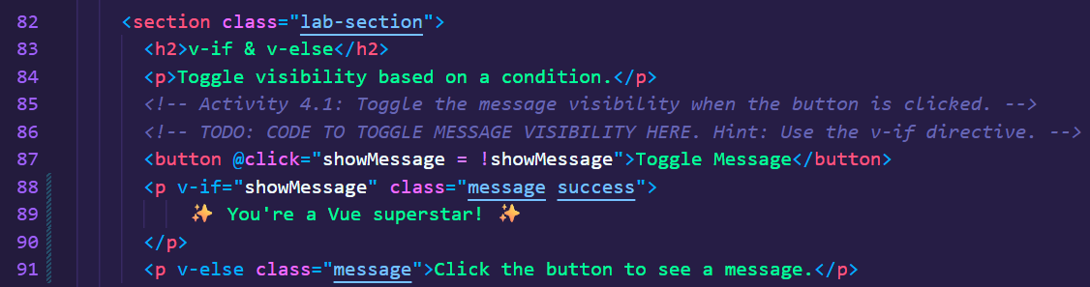
Task 4.1

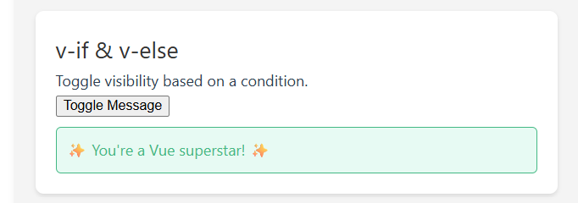
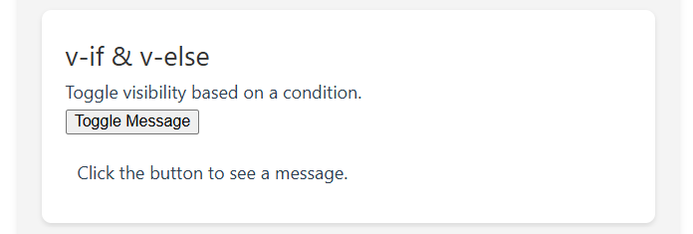

Task 6

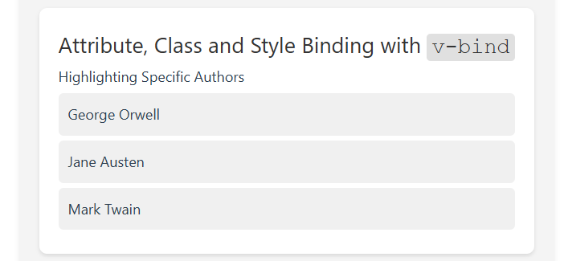
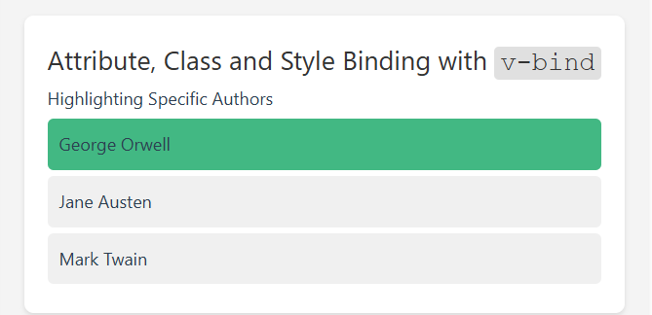
Task 6.1


